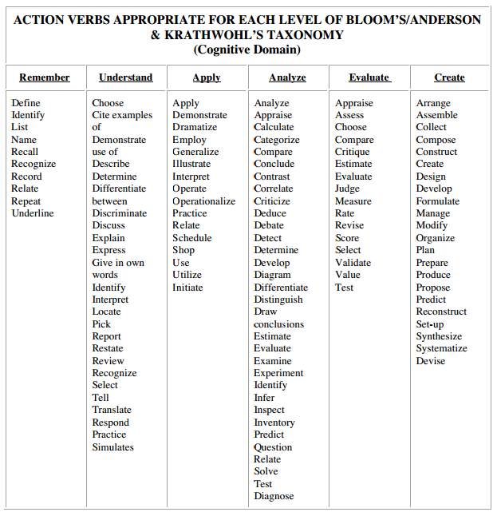
Found at http://www.personal.psu.edu/bxb11/Objectives/ActionVerbsforObjectives.pdf

